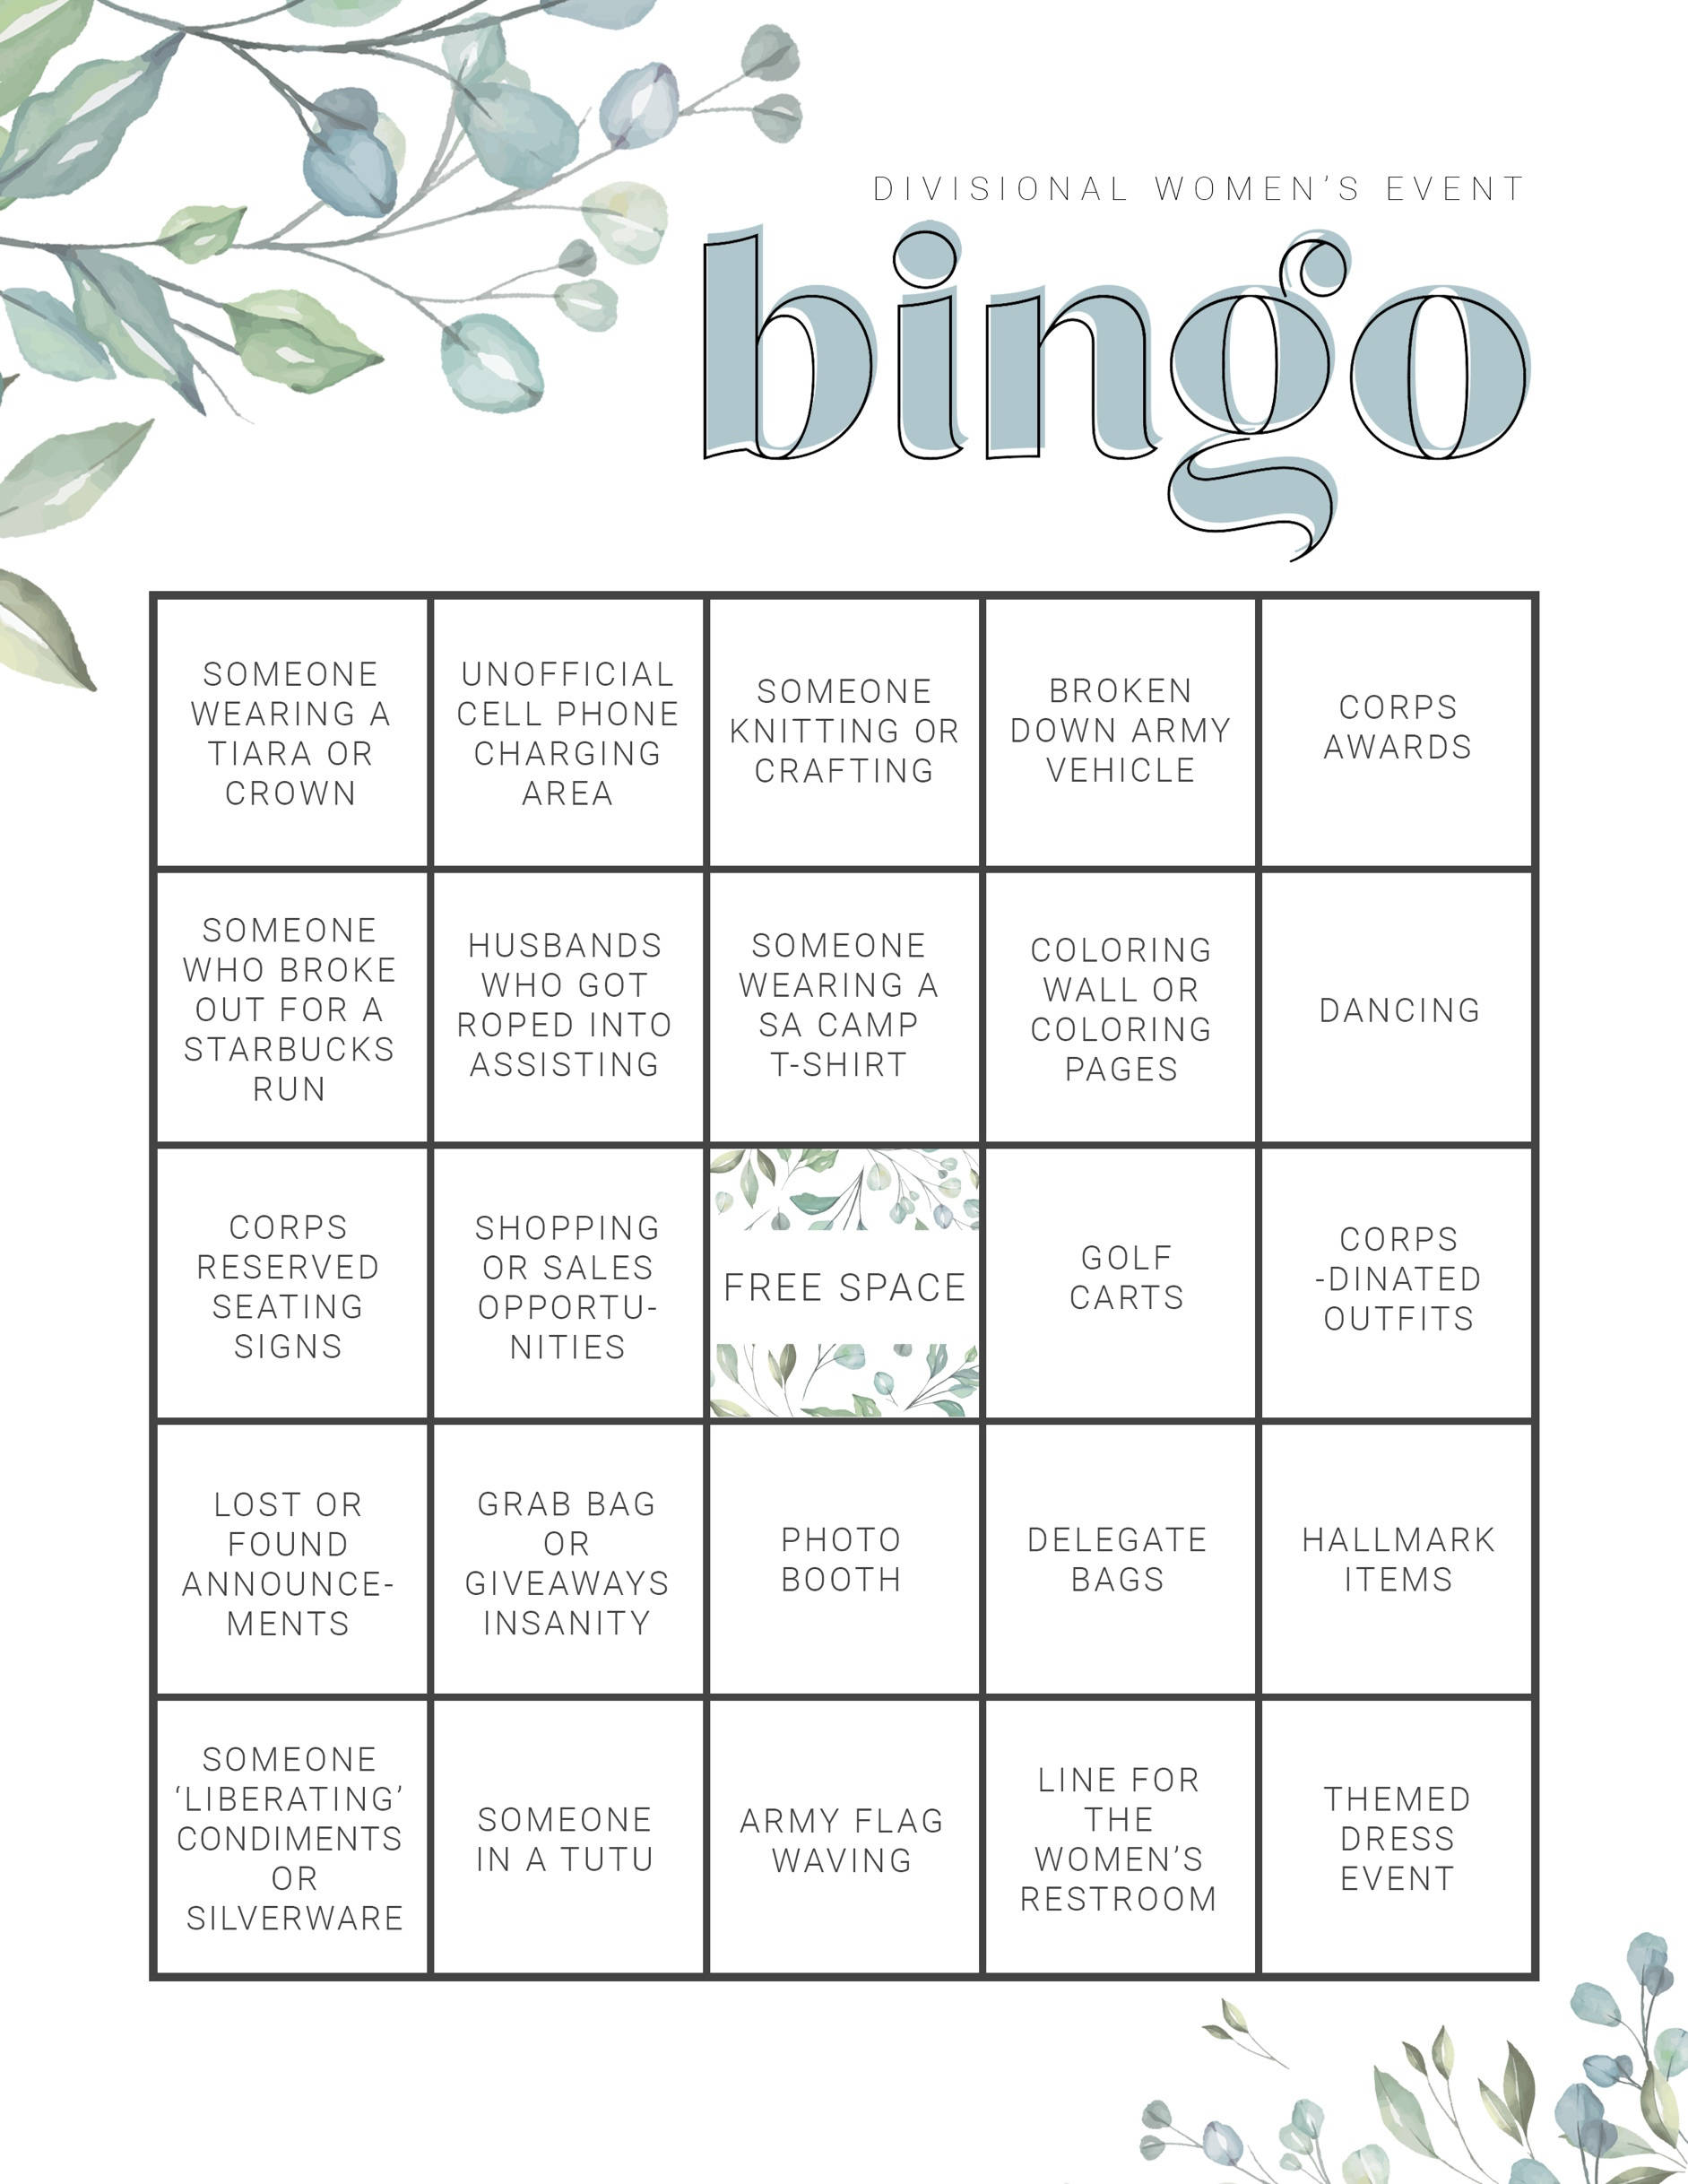

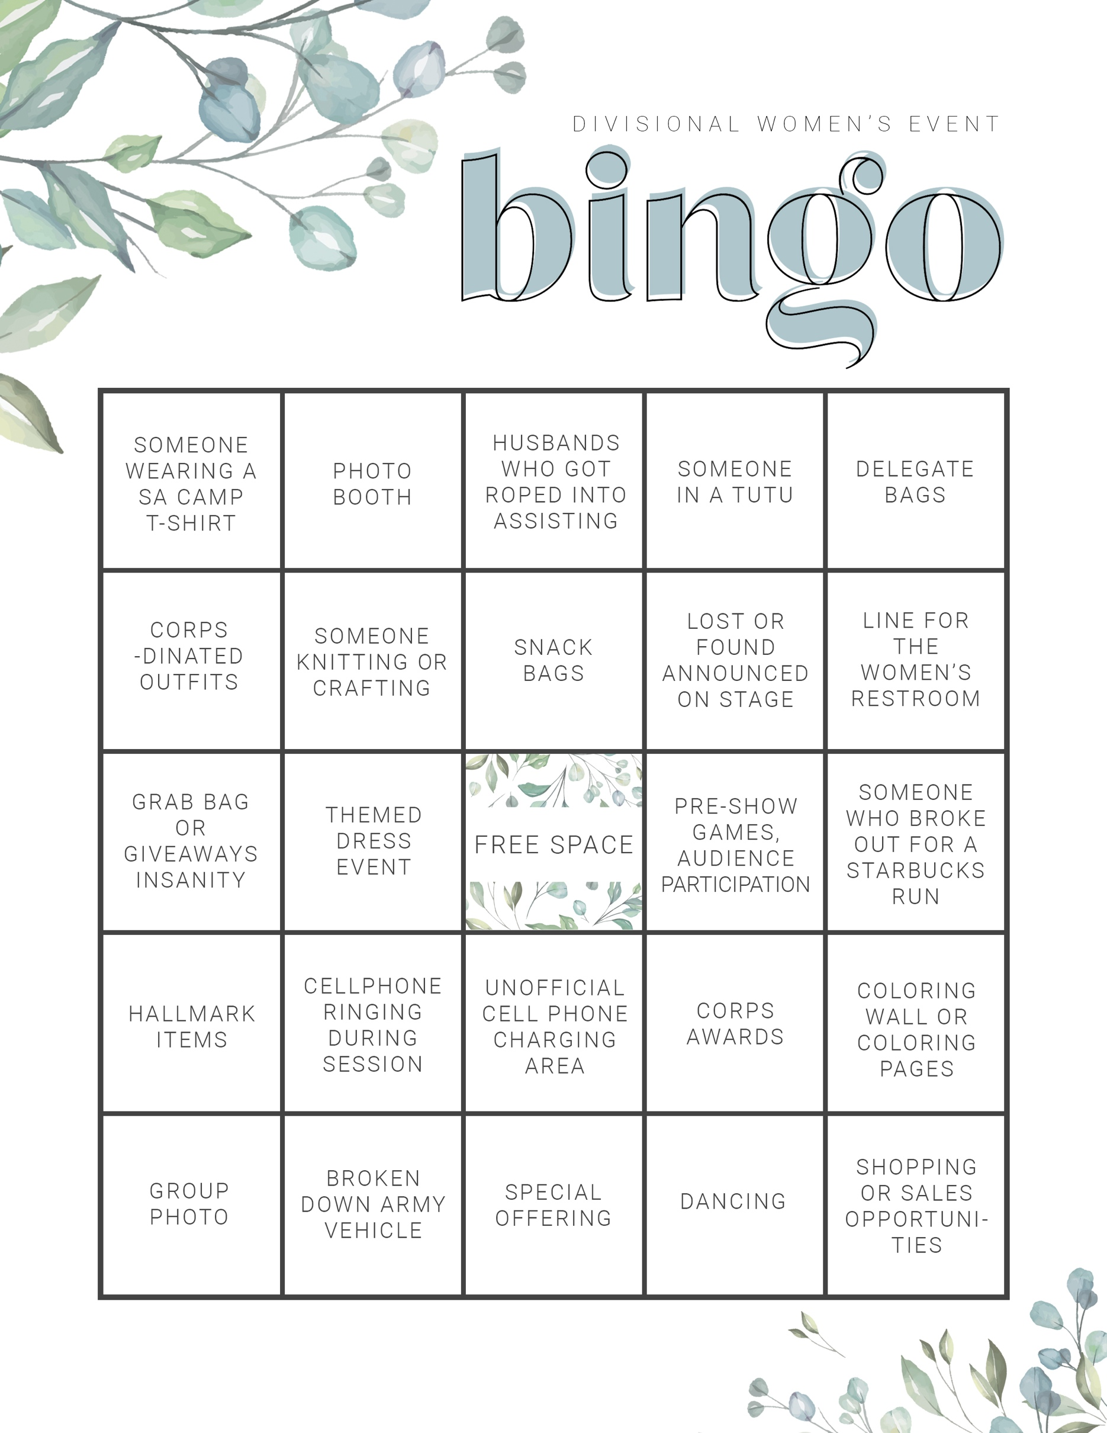

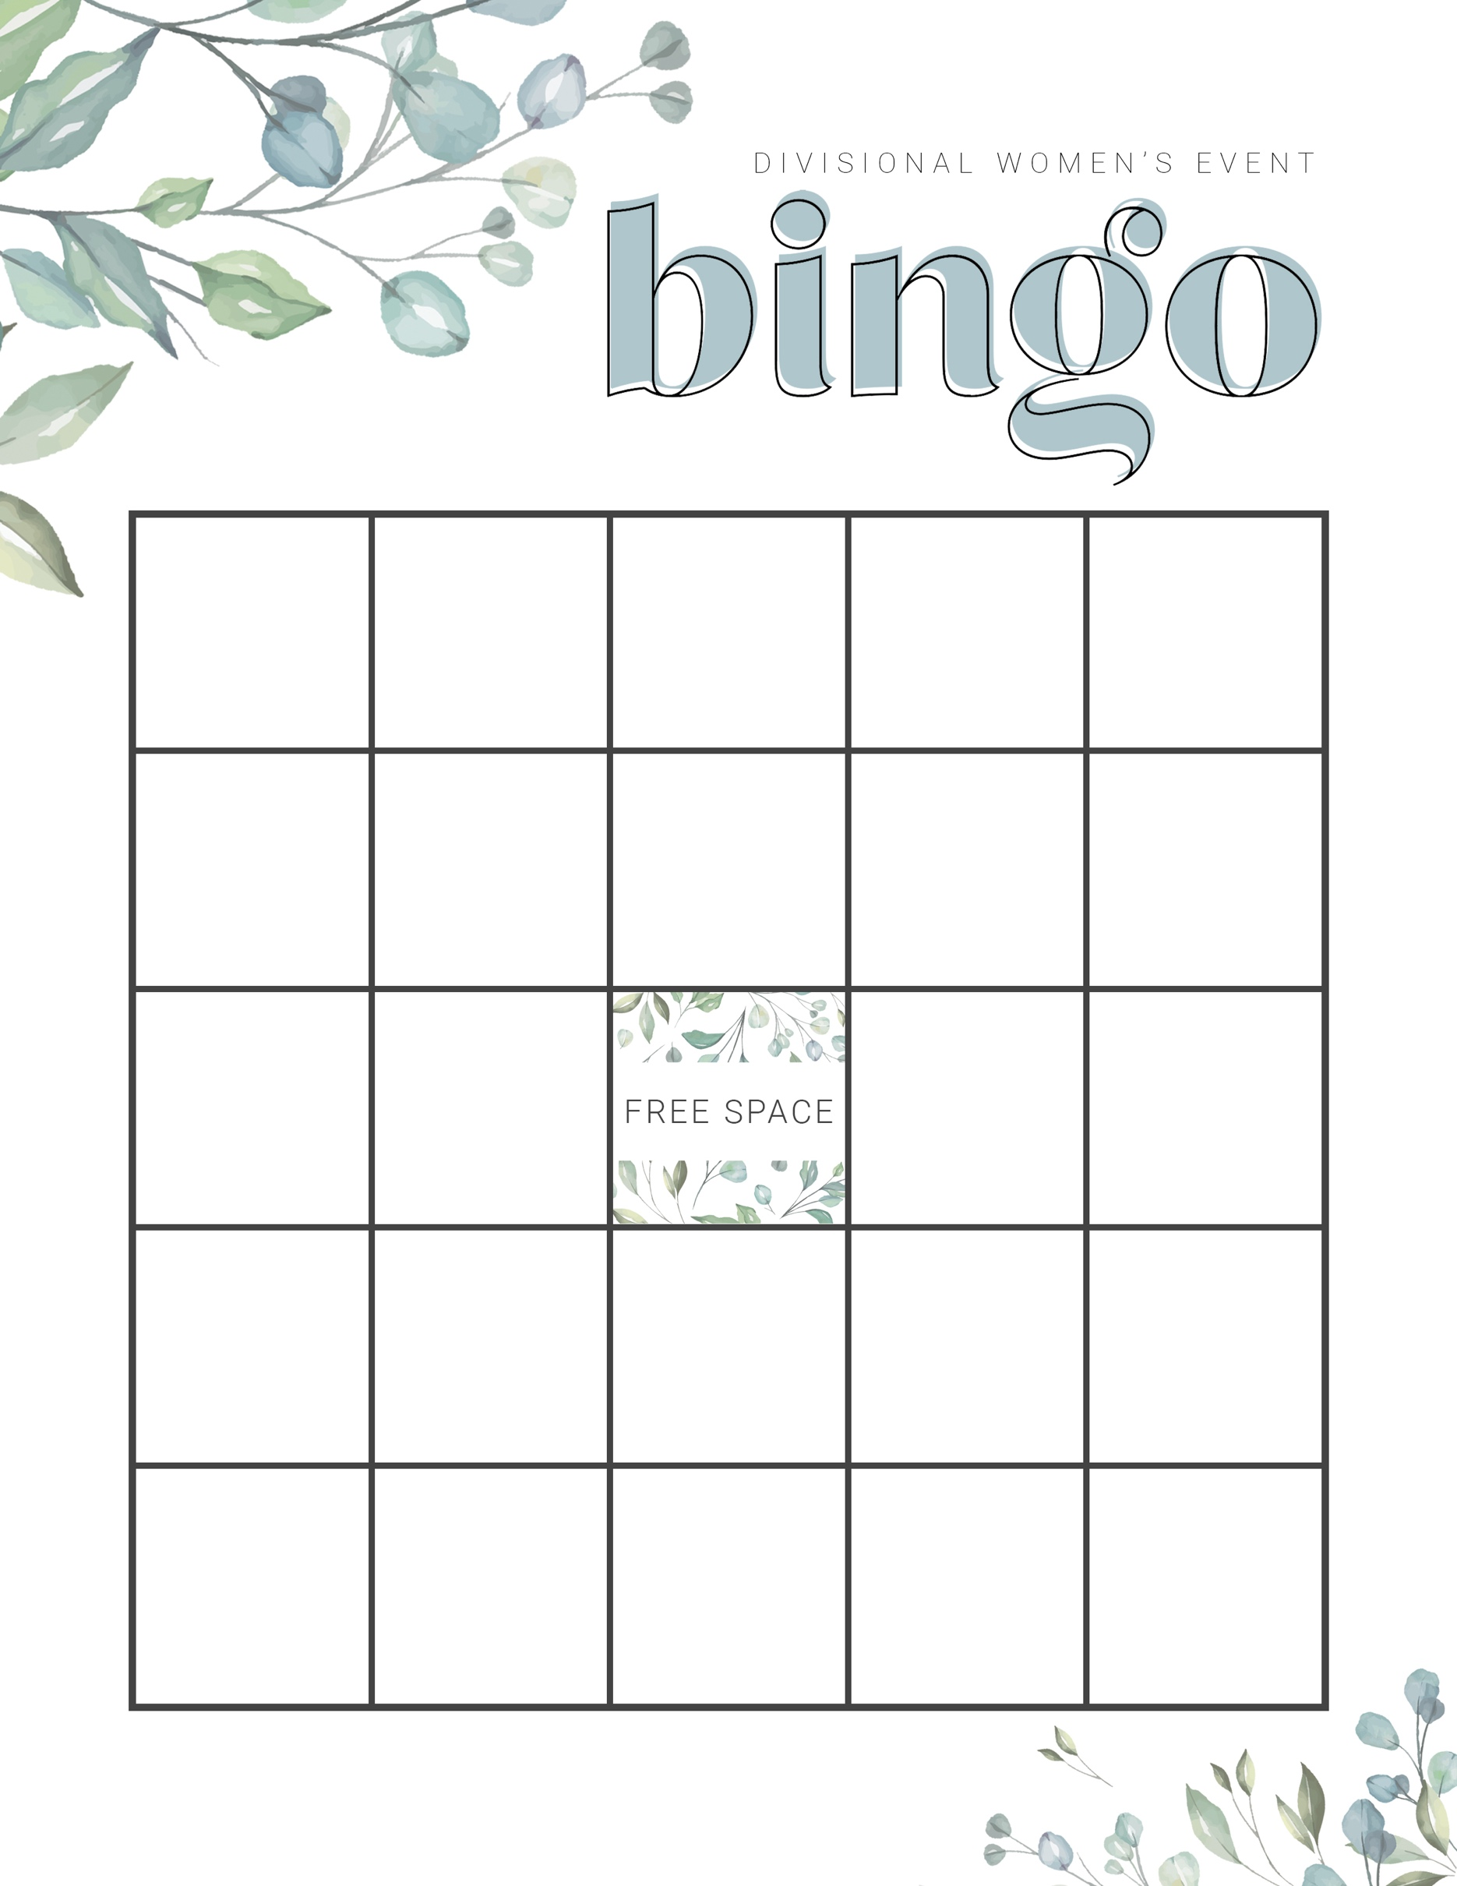

ENTER

TEXT

HERE

ENTER

TEXT

HERE

ENTER

TEXT

HERE

ENTER

TEXT

HERE

ENTER

TEXT

HERE

ENTER

TEXT

HERE

ENTER

TEXT

HERE

ENTER

TEXT

HERE

ENTER

TEXT

HERE

ENTER

TEXT

HERE

ENTER

TEXT

HERE

ENTER

TEXT

HERE

ENTER

TEXT

HERE

ENTER

TEXT

HERE

ENTER

TEXT

HERE

ENTER

TEXT

HERE

ENTER

TEXT

HERE

ENTER

TEXT

HERE

ENTER

TEXT

HERE

ENTER

TEXT

HERE

ENTER

TEXT

HERE

ENTER

TEXT

HERE

ENTER

TEXT

HERE

ENTER

TEXT

HERE

