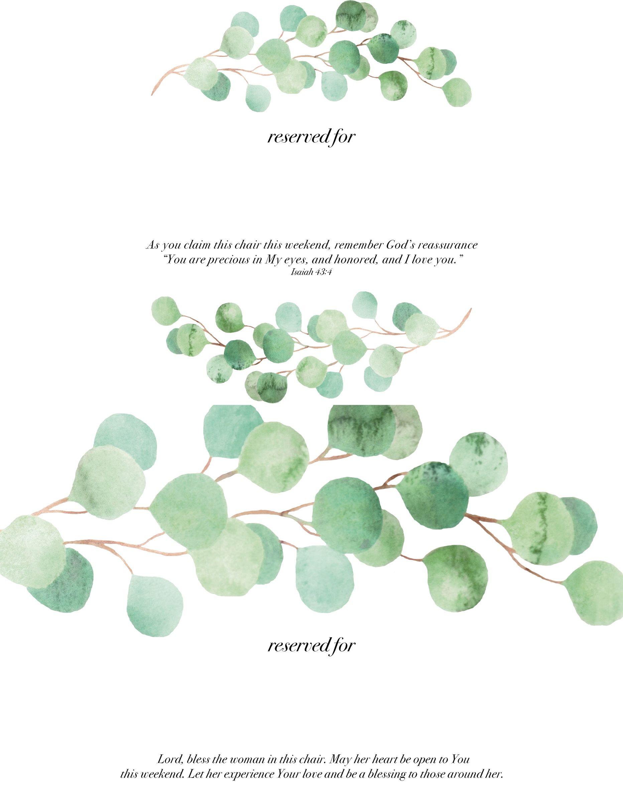

Catherine Booth

CLEARWATER

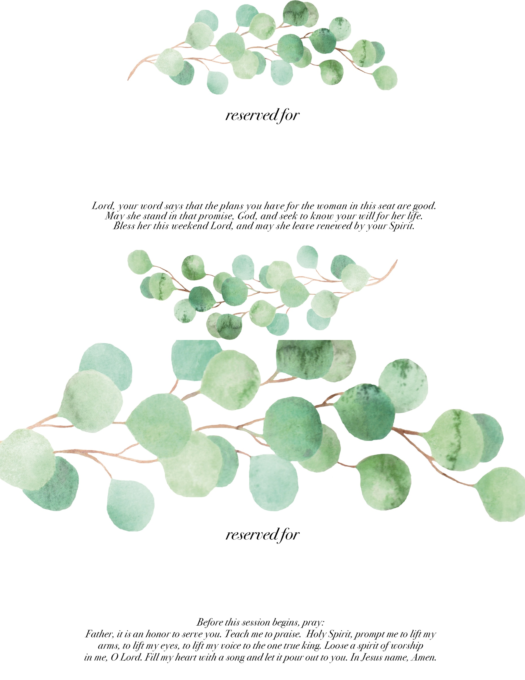

EVA BURROWS

griffin

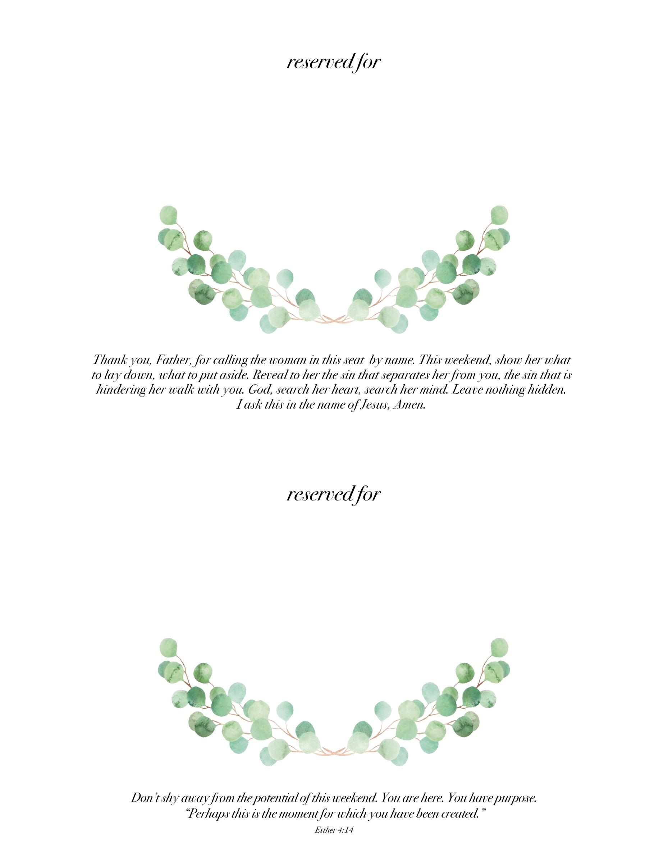

CHARLESTON

LUBBOCK